ASSESSMENT TASK

1. Write a PHP script to calculate the area and perimeter of a Rectangle, and display the result. Hints: The area of a Rectangle = length × width, perimeter = 2 × (length + width).

Code:

<!DOCTYPE html>

<html lang="en">

<head>

    <meta charset="UTF-8">

    <meta http-equiv="X-UA-Compatible" content="IE=edge">

    <meta name="viewport" content="width=device-width, initial-scale=1.0">

    <title>Document</title>

</head>

<body>

    <?php

     $Length = 10;

     $width  = 20;

     echo "Area of Rectangle is = "  .($Length* $width).

     "<br>";

     echo "Perimeter of Rectangle is = "  . 2 * ($Length + $width).

     "<br>";

     ?>

</body>

</html>

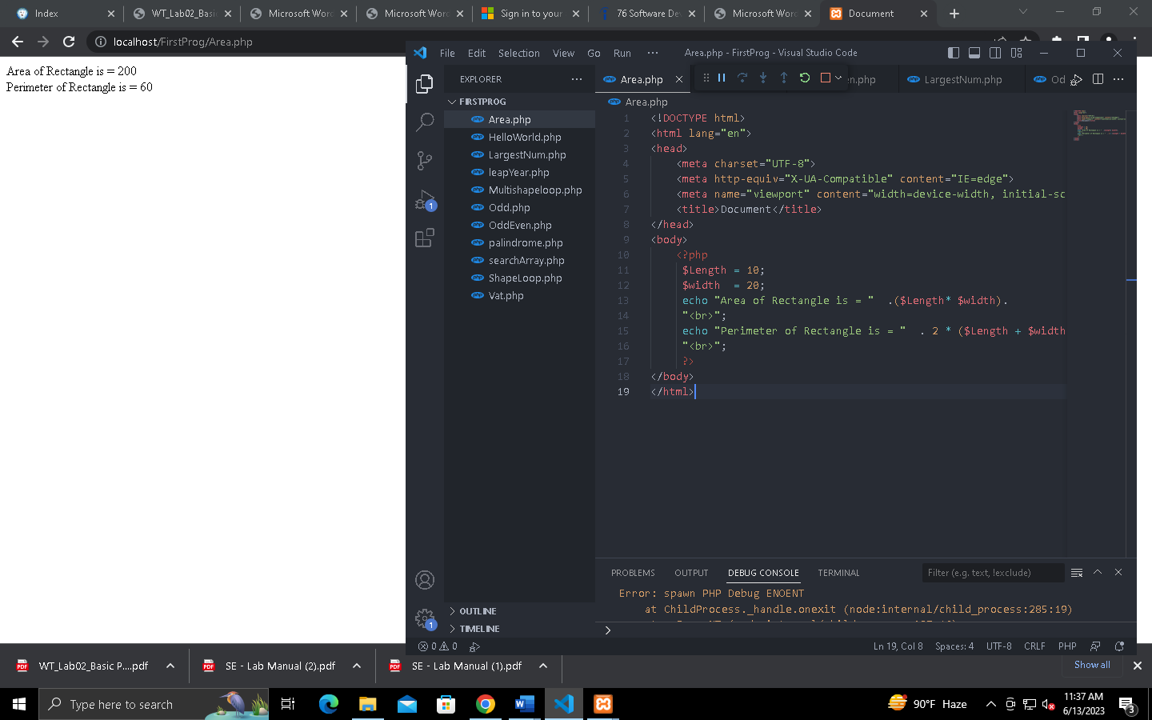

1. Write a PHP script to calculate the VAT (Value Added Tax) over an amount Hints: VAT = 15% of the amount

Code:

<!DOCTYPE html>

<html lang="en">

<head>

    <meta charset="UTF-8">

    <meta http-equiv="X-UA-Compatible" content="IE=edge">

    <meta name="viewport" content="width=device-width, initial-scale=1.0">

    <title>Document</title>

</head>

<body>

<?php

$vat = 15;

$priceExcludingVat = 10000;

echo "Vat for the amount is = " .($priceExcludingVat / 100) * $vat."<br>";

?>

</body>

</html>

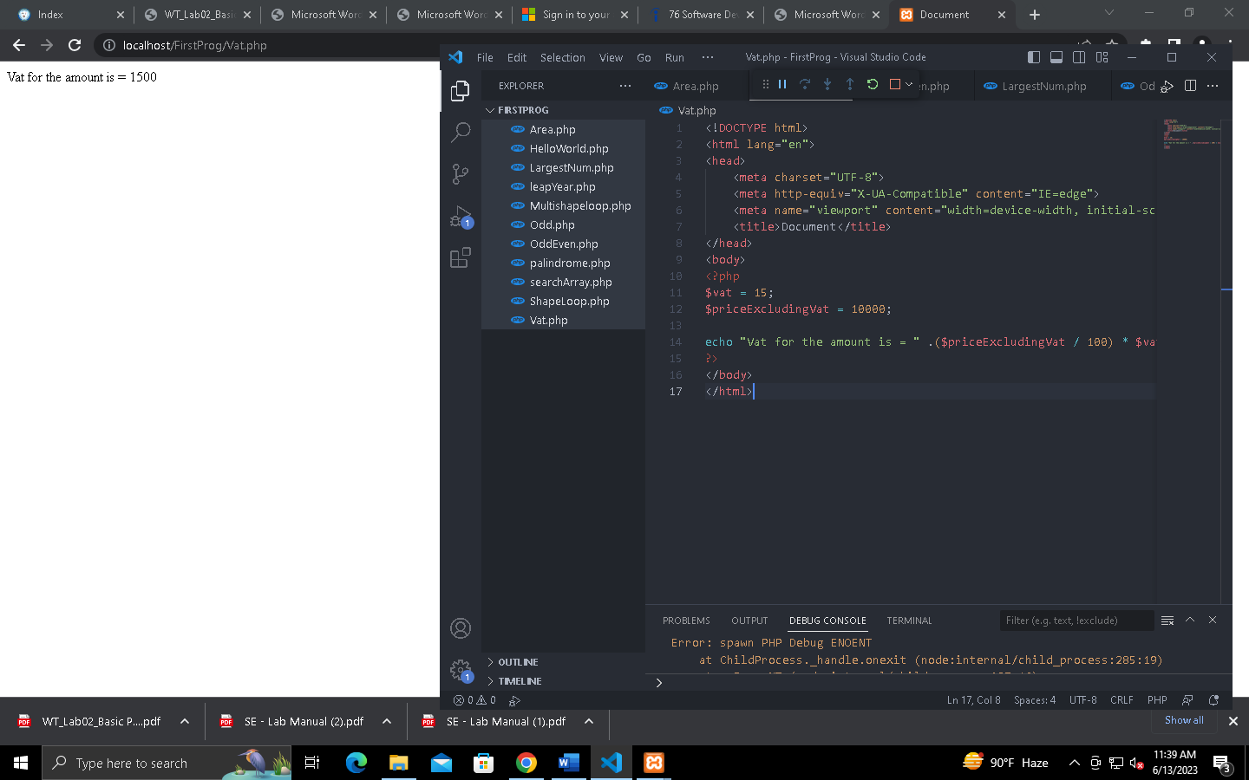

1. Write a PHP script to find whether a given number is odd or even Hints: use IF-ELSE

Code:

<!DOCTYPE html>

<html lang="en">

<head>

    <meta charset="UTF-8">

    <meta http-equiv="X-UA-Compatible" content="IE=edge">

    <meta name="viewport" content="width=device-width, initial-scale=1.0">

    <title>Document</title>

</head>

<body>

<?php

$number=100;

if($number%2==0)

{

 echo "The number is Even";

}

else

{

 echo "The number is Odd Number";

}

?>

</body>

</html>

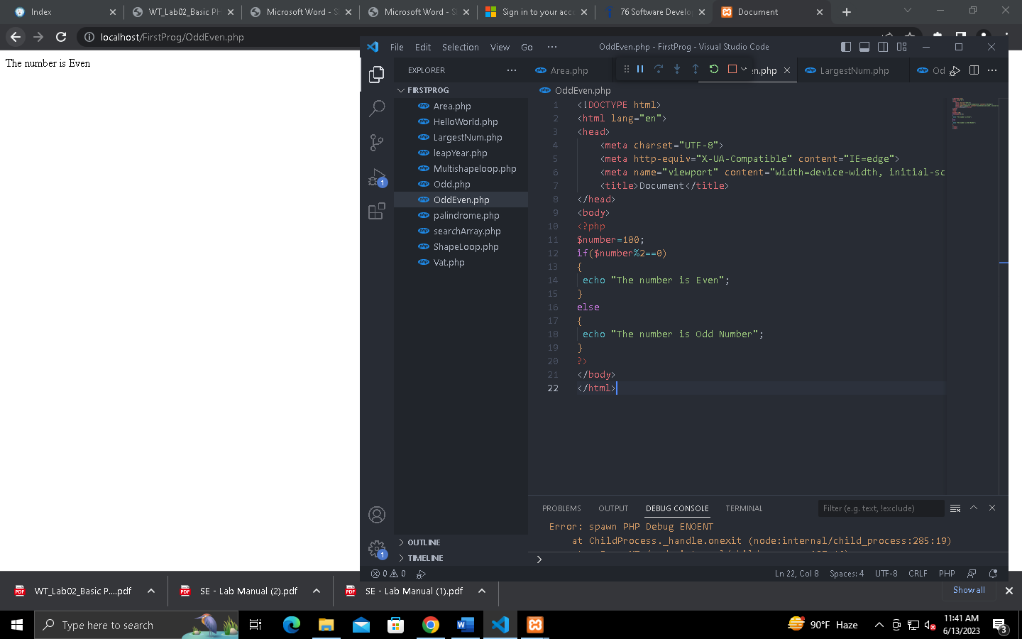

1. Write a PHP script to find the largest number from three given numbers Hints: use IF-ELSE

Code:

<!DOCTYPE html>

<html lang="en">

<head>

    <meta charset="UTF-8">

    <meta http-equiv="X-UA-Compatible" content="IE=edge">

    <meta name="viewport" content="width=device-width, initial-scale=1.0">

    <title>Document</title>

</head>

<body>

<?php

      $num1=30;

      $num2=10;

      $num3=29;

      if($num1>$num2 && $num1>$num3){

        echo  "Largest number is ", $num1;

      }

      else if($num2>$num1 && $num2>$num3){

          echo  "Largest number is ", $num2;

        }

        else

          echo "Largest number is ", $num3;

?>

</body>

</html>

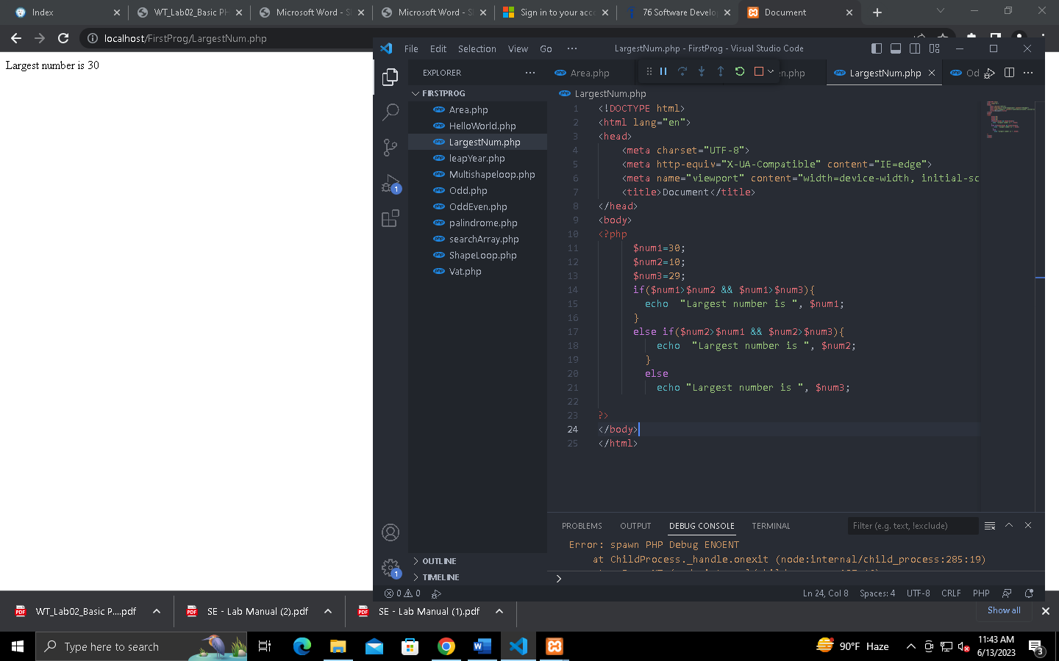

1. Write a PHP script to print all the odd numbers between 10 to 100 Hints: use LOOP & IFELSE

Code:

<!DOCTYPE html>

<html lang="en">

<head>

    <meta charset="UTF-8">

    <meta http-equiv="X-UA-Compatible" content="IE=edge">

    <meta name="viewport" content="width=device-width, initial-scale=1.0">

    <title>Document</title>

</head>

<body>

<?php

    echo "Odd numbers between 1 to 100 : ","<br>";

    for ($j=1; $j<=99; $j+=2){

        echo $j.", ";

    }

?>

</body>

</html>

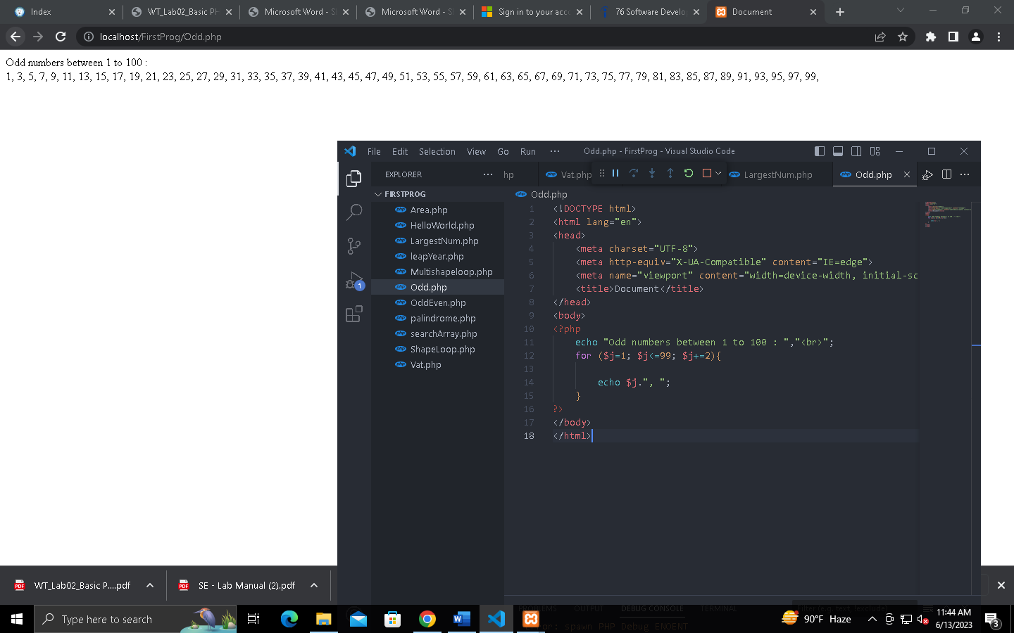

1. Write a PHP script to search an element from an array Hints: use LOOP, IF-ELSE & ARRAY

Code:

<!DOCTYPE html>

<html lang="en">

<head>

    <meta charset="UTF-8">

    <meta http-equiv="X-UA-Compatible" content="IE=edge">

    <meta name="viewport" content="width=device-width, initial-scale=1.0">

    <title>Document</title>

</head>

<body>

<?php

$array=array("a"=>"1","b"=>"2","c"=>"3","d"=>"4","e"=>"5","f"=>"6","g"=>"7");

echo array_search("7",$array);

?>

</body>

</html>

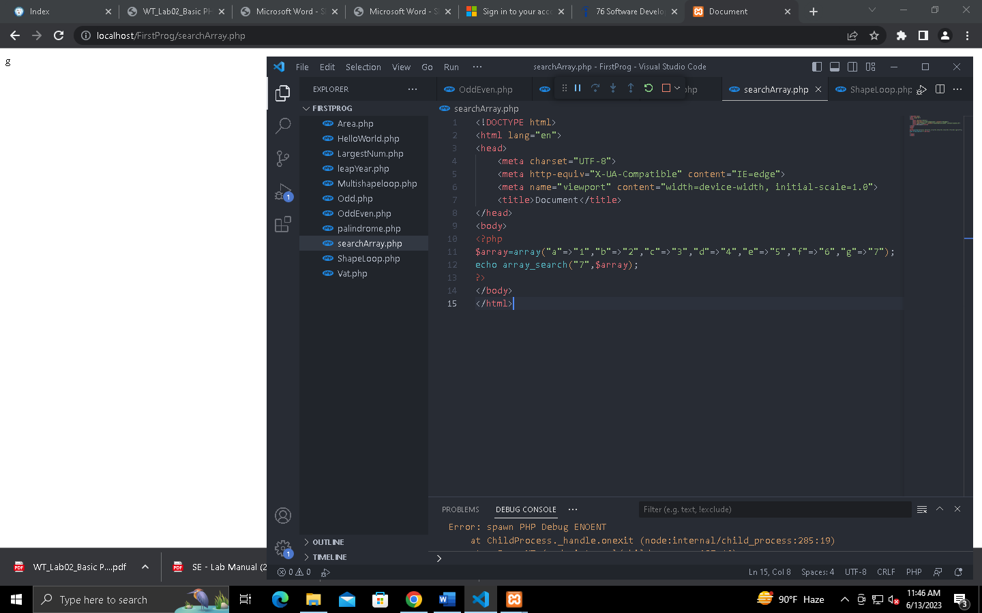

1. Print the following shapes Hints: use NESTED LOOP.

Code:

<!DOCTYPE html>

<html lang="en">

<head>

    <meta charset="UTF-8">

    <meta http-equiv="X-UA-Compatible" content="IE=edge">

    <meta name="viewport" content="width=device-width, initial-scale=1.0">

    <title>Document</title>

</head>

<body>

<?php

for($i=0;$i<=3;$i++){

    for($j=0;$j<=$i;$j++){

        echo "*";

    }

    echo "<br/>";

}

$n = 1;

for ($i = 0; $i < 3; $i++)

{

    for ($j = 0; $j <= $i; $j++ )

    {

        echo $n." ";

        $n = $n + 1;

    }

    echo "<br/>";

}

$c = 65; */*Initializing ASCII value of (A) */*

for ($i = 0; $i < 3; $i++)

{

    for ($j = 0; $j <= $i; $j++ )

    {

        echo chr($c)." ";

        $c = $c + 1;

    }

    echo "<br/>";

}

?>

</body>

</html>

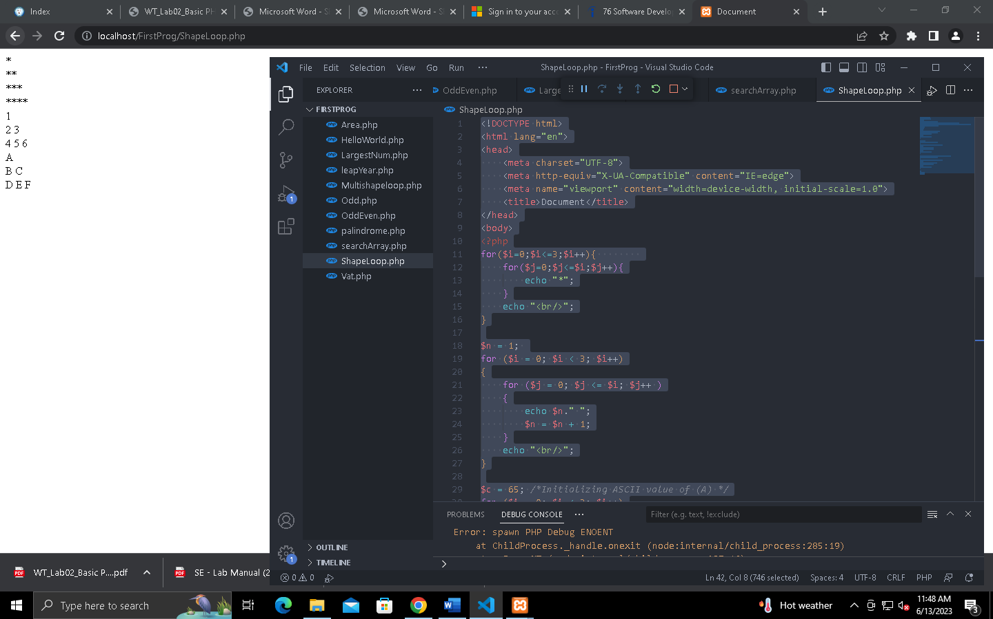

1. Declare a 2D array like following and print the following shapes Hints: use 2D ARRAY & NESTED LOOP.

Code:

<!DOCTYPE html>

<html lang="en">

<head>

    <meta charset="UTF-8">

    <meta http-equiv="X-UA-Compatible" content="IE=edge">

    <meta name="viewport" content="width=device-width, initial-scale=1.0">

    <title>Document</title>

</head>

<body>

<?php

$arr = array(

    array(1,2,3,'A'),

    array(1,2,'B','C'),

    array(1,'D','E','F'));

for ($i = 0; $i < 4; $i++)

{

    for ($j = 0; $j <= $i; $j++ )

    {

        echo $arr[$i][$j];

    }

    echo "<br/>";

}

?>

</body>

</html>

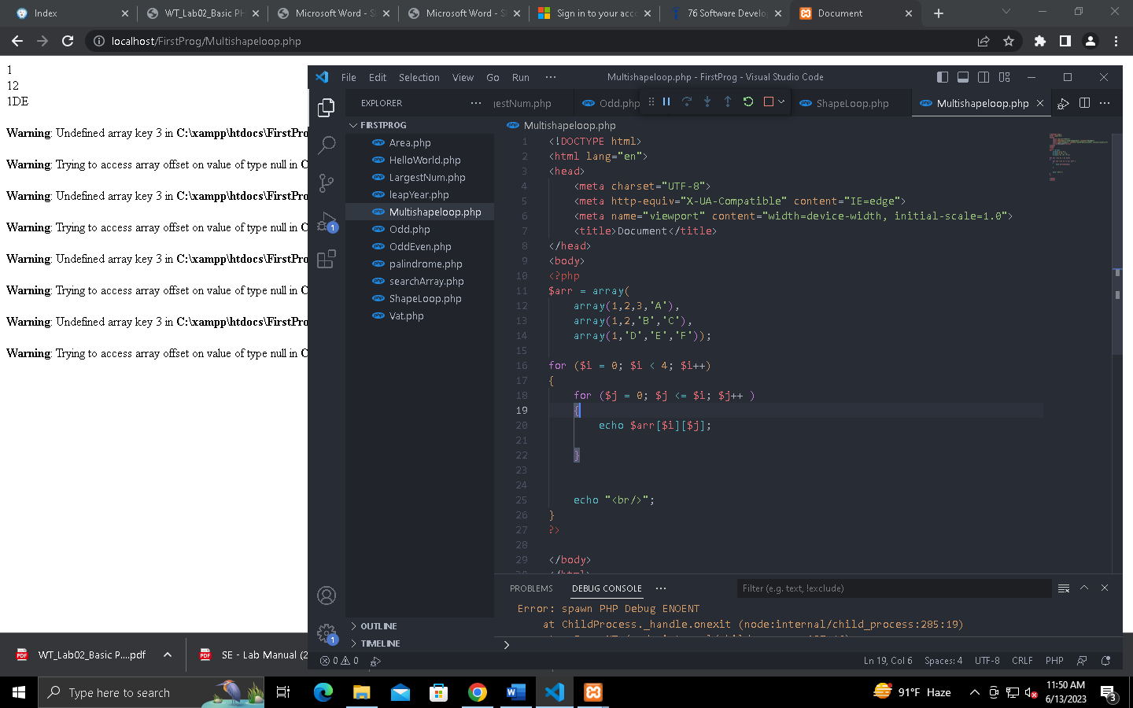

1. Implement a PHP function that checks if a given string is a palindrome (reads the same forwards and backwards). The function should return true if the string is a palindrome, and false otherwise

Code:

<!DOCTYPE html>

<html lang="en">

<head>

    <meta charset="UTF-8">

    <meta http-equiv="X-UA-Compatible" content="IE=edge">

    <meta name="viewport" content="width=device-width, initial-scale=1.0">

    <title>Document</title>

</head>

<body>

<?php

function check_palindrome($string)

{

  if ($string == strrev($string))

  echo "True";

  else

  echo "False";

}

echo check_palindrome('eye')."\n";

?>

</body>

</html>

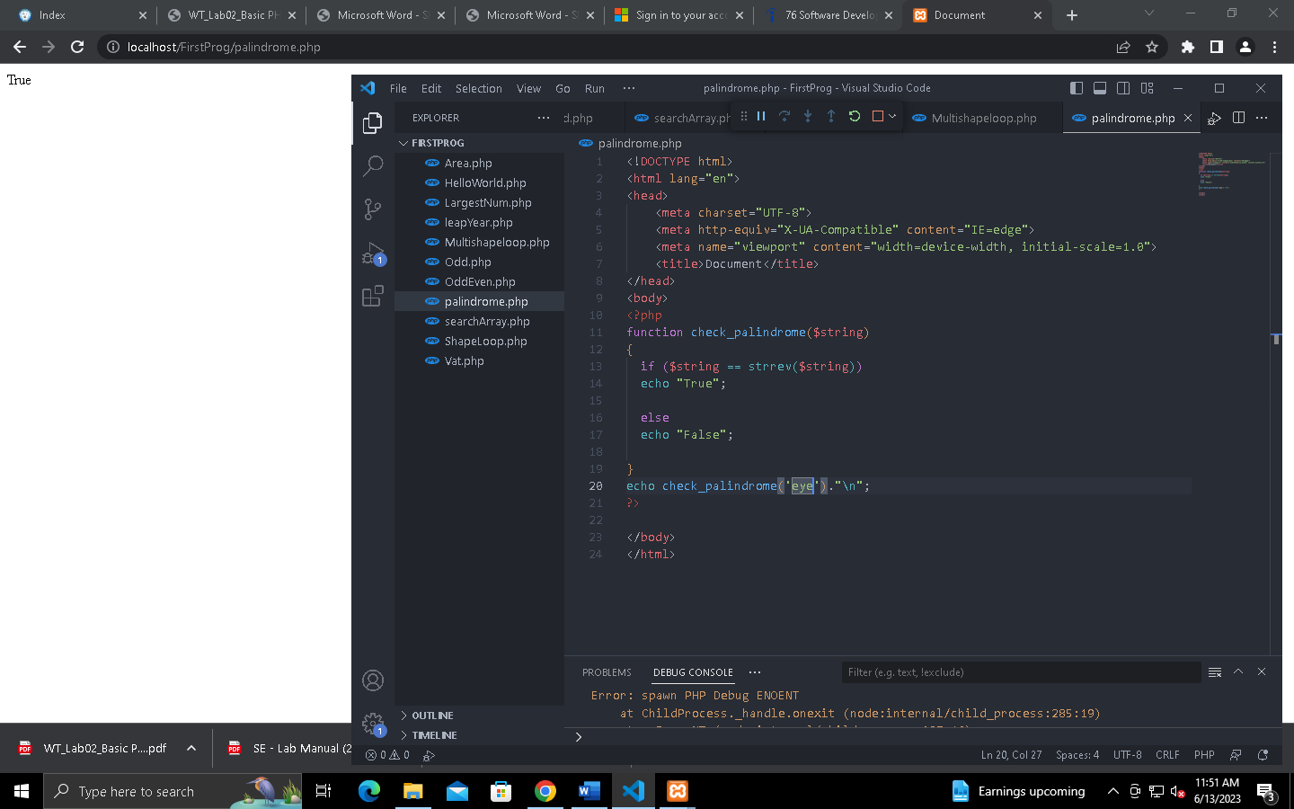

1. Write a PHP function to whether it is a leap year or not, returning true or false accordingly.

Code:

<!DOCTYPE html>

<html lang="en">

<head>

    <meta charset="UTF-8">

    <meta http-equiv="X-UA-Compatible" content="IE=edge">

    <meta name="viewport" content="width=device-width, initial-scale=1.0">

    <title>Document</title>

</head>

<body>

<?php

   function year_check($my_year){

      if ($my_year % 400 == 0)

         print("TRUE");

      else if ($my_year % 100 == 0)

         print("FALSE");

      else if ($my_year % 4 == 0)

         print("TRUE");

      else

         print("FALSE");

   }

   $my_year = 2000;

   year_check($my_year);

?>

</body>

</html>

